Mobile No: 09357778269 E-Mail: rajinder.pundir12@gmail.com

RAJINDER SINGH PUNDIR
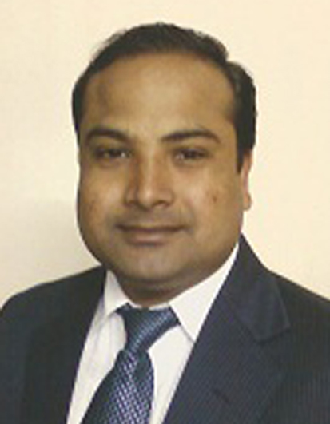

Seeking challenging role in sales & marketing with a frontline organization.

A Brief Overview

years of working experience in Marketing & sales, I have learnt how to operate in a fast paced marketing and sales environment. Familiar with how to achieve assigned sales targets through existing and uncovered customers, to increase the penetration of company’s products in the market. How to Build strong relationships with the channel partners through innovative idea of presentations. Finding new ways &plans to get growth on the monthly base. Working on and successfully managing stress full situations.

Job Title : Sr. Business Manager
Orginazation : Abbott (I) Pvt.Ltd.
Duration : July 2007 to till now
Job Descriptio: Dealing with Doctors & stockiest and generating business through them,
Promoting Products on the Scientific Backgrounds, Customizing sales, Applying Sales techniques to achieve the target.

- Identification of potential clients and making customized sales presentations, thereby being responsible for target achievement through superior client servicing.
- Presenting our products to the clients, highlighting the key benefits.
- Making and implementing different marketing & sales strategies to create the demand of product.
- Building and maintaining strong relationships with them.
- Keeping abreast top management about competitor strategies.
- Covering government institute (PG.I.M.E.R D”MART ,BIG BAZAR AND CSD Canteen for otc segment sku –PEDISURE to generate internal sales and manage supply and maintain good relation with Purchase officer to generate business.
- Achieved best sales target achiever award in 2016 (international Award 2016,and best BI brand achiever award in 2019.2022,2023 double diamond ticket at Singapore & Thailand . .
- Creating the demand of the product by building relationship with customers and other channel partners.

Organization : LIFESTAR PHARMA PVT.LTD .

Job Title : Medical Representative
Total Duration : Jan2006 to July 2007
Job Description: Dealing with Doctors &stockiest and generating business through them, Promoting products, customized sales, applying sales technique to achieve our target.

- Worked to get prescription for products to achieve the given budget by implementing different marketing technique.

Organization : SAPIENS LABS PVT.LTD.
Job Title : Medical Representative
Total Duration :Aug 2004 to Jan2006
Job Description: Dealing with retailers & stockiest and generating business through them,
Promoting products, customized sales, applying sales technique to achieve our target.

- Creating the demand of the product by building relationship with customers and other channel partners.

STRENGTHS

- Competent enough to work in highly
- stressful and competent environment with skills to rapidly recognize the needs and aspirations of customers and properly build a sales strategy.
- Result oriented with strong analytical & problem solving approach.
- Strive for perfection, Positive attitude, adaptability, interpersonal & communication skills are my major strengths.
- Excellent at relationship management.

Academic Credentials

Sr. no | Qualification | Institution  Organization | Uni/Board | Year of passing
1 | Graduation with Office Management . | S.D.Collage Ambala Cantt . | Krukeshetra | 2002
2 | 10+2 | Army School Ambala Cantt. | CBSE | 1999
3 | Metric | Army School Ambala Cantt | CBSE | 1997

Personal Vita

Date of Birth : 12 Feb 1982
Gender : Male
Marital Status : Married Nationality : Indian
Languages Known : English, Hindi and Punjabi
Technical skills : Familiar with MS-Office, Net Surfing and all.
Hobbies : Reading books, listening music.
Permanent Address : H.no 454 Palm City Sec -5 ,DeraBassi
Passport No. U3235019 (India)

Place-Chandigarh Rajinder Singh Pundir

